Let Your MIND WORK!
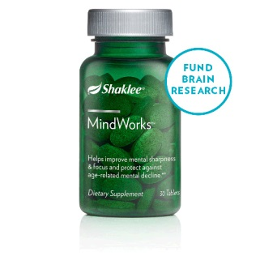Thank you for participating! Shaklee’s MindWorks has been in development for 5 years and put through rigorous testing and clinical studies. Please enter your starting date and rate the following on a scale of 1 to 5 - with 1 being most easily done. After 2 months of use, please check again. We are looking forward to receiving your feedback.
Start Date: |  | Rating
End Date:_____________________________  Description |  | Day 1  1 (easily done) –  5 (not easy) | Day 60  1 (easily done) –  5 (not easy)
1. | Able to focus on details easily – crosswords, reading comprehension, directions
2. | Recall names easily
3. | React quickly to situations – process new info and react
4. | Energized sense of well-being and ability to concentrate
5. | Recall of short term information – where you put things – what you forgot several days ago
6. | Restful sleep – manifest dreams
Please comment on other benefits or observations below: Note- some people report increased energy, a more positive attitude, some may notice a slight headache as their brain circulation improves, and some report less appetite and cravings. Be observant of other changes as well. Please write your personal experiences the back of this page.
Mail this back to us to receive your FREE product with your next order as a thank you! Your choices are:
Herbal Blend Cream OR Meadow Blend Cleansing Bar 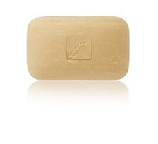
Send form to: Elena Giacomin Dennis
2 Buena Ventura Place
Santa Fe, NM 87508-8377 505-690-2327

