Finally: A missing link between vitamin D and prostate cancer

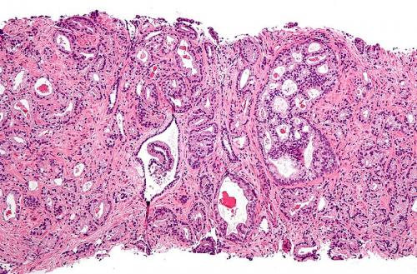
Micrograph showing prostatic acinar adenocarcinoma (the most common form of prostate cancer) Credit: Wikipedia
University of Colorado Cancer Center study recently published in the journal Prostate offers compelling evidence that inflammation may be the link between Vitamin D and prostate cancer. Specifically, the study shows that the gene GDF-15, known to be upregulated by Vitamin D, is notably absent in samples of human prostate cancer driven by inflammation.
"When you take Vitamin D and put it on prostate cancer cells, it inhibits their growth. But it hasn't been proven as an anti-cancer agent. We wanted to understand what genes Vitamin D is turning on or off in prostate cancer to offer new targets," says James R. Lambert, PhD, investigator at the CU Cancer Center and associate research professor in the CU School of Medicine Department of Pathology.
Since demonstrating that Vitamin D up-regulates the expression of GDF-15, Lambert and colleagues, including Scott Lucia, MD, wondered if this gene might be a mechanism through which Vitamin D works in prostate cancer. Initially it seemed as if the answer was no.
"We thought there might be high levels of GDF-15 in normal tissue and low levels in prostate cancer, but we found that in a large cohort of human prostate tissue samples, expression of GDF-15 did not track with either normal or cancerous prostate tissue," Lambert says.
But then the team noticed an interesting pattern: GDF-15 was uniformly low in samples of prostate tissue that contained inflammation.
"Inflammation is thought to drive many cancers including prostate, gastric and colon. Therefore, GDF-15 may be a good thing in keeping prostate tissue healthy – it suppresses inflammation, which is a bad actor potentially driving prostate cancer," Lambert says.
The study used a sophisticated computer algorithm to analyze immunohistochemical (IHC) data, a task that in previous studies had been done somewhat subjectively by pathologists. With this new technique, Lambert, Lucia and colleagues were able to quantify the expression of the GDF-15 protein and inflammatory cells by IHC staining on slides taken from these human prostate samples.
Additionally encouraging is that the gene GDF-15 was shown to suppress inflammation by inhibiting another target, NFkB. This target, NFkB, has been the focus of many previous studies in which it has been shown to promote inflammation and contribute to tumor formation and growth; however, researchers have previously been unable to drug NFkB to decrease its tumor-promoting behavior.
"There's been a lot of work on inhibiting NFkB," says Lambert. "Now from this starting point of Vitamin D in prostate cancer, we've come a long way toward understanding how we might use GDF-15 to target NFkB, which may have implications in cancer types far beyond prostate."

